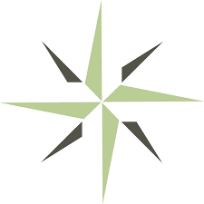
DEAC CONSUMER INFORMATION DISCLOSURE FORM
General Information:

Name of Institution: Holmes Institute School of Consciousness Studies

Address: 573 Park Point Drive, Golden, CO 80401

Year Founded: 1997

First Accredited: 2003

President: Kim Kaiser, EdD

Accreditation (s) and Agency E-mail Contact Information:
Distance Education Accrediting Commission info@deac.org

Participation in Funding Programs: N/A

Mission and Description:

Institution Mission Statement: Holmes Institute offers quality distance education graduate programs in consciousness studies to spiritual leaders preparing for service in the global community.

Areas of Special Focus: Consciousness Studies

Description of Institution: Non-Profit, affiliated with the Centers for Spiritual Living
Student Demographic Profile: Adult Learners

Courses/Programs/Degrees: Master of Consciousness Studies - 54 quarter credit hours for completion

Certificate in Spiritual Education - 30 quarter credit hours for completion

Average Program Tuition/Cost per credit hour: Master of Consciousness Studies - $10,065/$175 per unit

Certificate in Spiritual Education - $6,025/$175 per unit

Success Indicators:

Completion/Graduation Rate for ALL programs/courses: .86

Percentage of students surveyed who responded that:

Pass rate in ______ licensure exam : N/A
Acceptance at other schools/universities: N/A
Received job promotion or salary increase: N/A
Gained salary increase as a result: N/A
Pass rates on exams (GRE, SAT, LSAT, etc): N/A
Gained a new job as a result: N/A

Results from other assessments:

Other indicators:
Administrative review of exam results and contracts signed

Gained a new job as a result: 74 %

Pass rate 100% in Centers for Spiritual Living licensure exam

